Mappings:

**Mappings are key value pair which can be used in Resources section. We can dynamically choose the values using mappings at run time**

Intrinsic functions:

* AWS CloudFormation provides several built-in functions that help you manage your stacks.
* Use intrinsic functions in your templates to assign values to properties that are not available until runtime.
* You can use intrinsic functions only in specific parts of a template.
* Currently, you can use intrinsic functions in resource properties, outputs, metadata attributes, and update policy attributes. You can also use intrinsic functions to conditionally create stack resources.

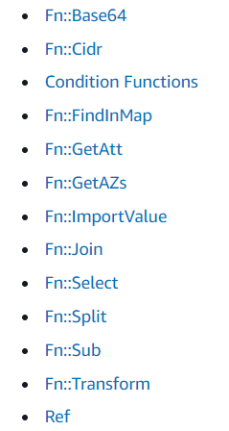

Example:

Mappings:  
 ImageIdMapping:  
 ap-south-1:  
 LINUX2AMI: ami-0470e33cd681b2476  
 us-east-1:  
 LINUX2AMI: ami-0323c3dd2da7fb37d  
 us-east-2:  
 LINUX2AMI: ami-0f7919c33c90f5b58  
  
Resources:  
 MyEC2:  
 Type: AWS::EC2::Instance  
 Properties:  
 ImageId: !FindInMap  
 - ImageIdMapping  
 - !Ref 'AWS::Region'  
 - LINUX2AMI  
 InstanceType: t2.micro  
 SecurityGroups:  
 - default

Example #2 :

Parameters:  
 Environment:  
 Type: String  
 Default: dev  
 AllowedValues:  
 - dev  
 - test  
Mappings:  
 ImageMap:  
 ap-south-1:  
 LINUX2AMI: ami-0470e33cd681b2476  
 us-east-1:  
 LINUX2AMI: ami-0323c3dd2da7fb37d  
 us-east-2:  
 LINUX2AMI: ami-0f7919c33c90f5b58  
  
 InstanceTypeMap:  
 dev:  
 InstanceType: t2.micro  
 test:  
 InstanceType: t2.nano  
  
Resources:  
 MyEC2:  
 Type: AWS::EC2::Instance  
 Properties:  
 ImageId: !FindInMap  
 - ImageMap  
 - !Ref 'AWS::Region'  
 - LINUX2AMI  
 InstanceType: !FindInMap  
 - InstanceTypeMap  
 - !Ref Environment  
 - InstanceType  
 SecurityGroups:  
 - default